Shaina Kale, COTA/L
shaina@locusfct.com

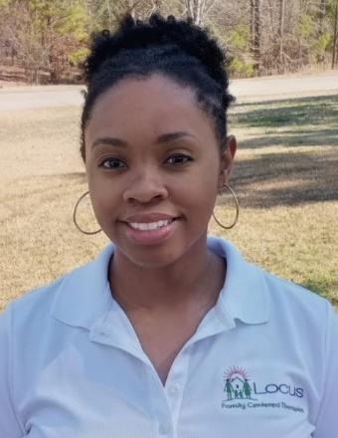
Shaina graduated from OTA school at Pitt Community College in 2010 and has since worked in a variety of settings including home health. Shaina has a heart to help families and young children have the highest quality of life possible and is excited to apply her experiences and passions to the field of pediatrics. Shaina brings creativity, excitement, and a strong clinical background to work with your child and your family to help best meet your goals.

She is particularly tuned into the needs of families as a result of:

- educational and clinical background including OTA pediatric coursework and fieldwork
- skilled at implementing an evidence based, family-centered care model
- certified in CPR through the American Heart Association
- parenting her own young children!

Shaina is experienced and comfortable serving families whose children have the following diagnoses: Autism, Sensory Processing Disorder, Developmental Delay/Fine Motor Skills, Genetic Conditions, Feeding Dysfunctions, Family Centered Care, Prematurity, and Cerebral Palsy/Musculoskeletal
_____________________________________________________

Shaina is supervised and mentored by Dr. Beth Hathaway OTD OTR/L, a veteran OT with over 35 years of pediatric experience. As the only known private pediatric practice owner in North Carolina with a clinical doctorate degree in OT, Beth understands how to deliver evidence-based therapy. Her doctoral degree included research on how to equip and mentor providers of early intervention to provide family centered care, a topic which she is passionate about and remains a core value of therapists at Locus Family Centered Therapies. Beth has intentionally created a staff mentoring program at Locus which includes frequent contact to discuss caseloads, the ability to attend sessions alongside her staff, and contributing to their continued education through workshops and trainings. Beth mentors Shaina and other staff weekly, providing valuable experience and insights to make sure your experience with Locus is rewarding.

